

Rhodesian Services Association Incorporated
February 2008 Newsletter
PO Box 13003, Tauranga 3141, New Zealand.
Web: http://www.rhodesianservices.org/
E-mail hbomford@clear.net.nz
Phone +64 7 576 9500 Cell +64 21 045 8069 Fax +64 7 576 9501
Please Note that all previous newsletters are available at http://www.rhodesianservices.org/Newsletters.htm

Greetings

Thank you for all your positive feedback from the last newsletter. It never ceases to amaze me how well received these newsletters are. A lot of work goes into each one and your feedback does a lot to alleviate the load. We can always use articles from the subscribers so please do not hesitate to send material in.

There are now over 700 subscribers to this newsletter spanning every continent with the exception of Antarctica. This number grows on a daily basis. We welcome new subscribers and encourage you to become a financial member of the Rhodesian Services Association Incorporated as well. Financial membership is currently NZ$5 per annum with membership renewable every year in October. For overseas members such a small sum of money is more easily paid via PayPal or by personal cheque. An unfortunate problem is that our bank will not accept cheques from South Africa currently. Contact me for more information if you wish.

I recently received 'The Pride', the Australian Branch of the Rhodesian Light Infantry Association's newsletter, in which I read about the benefits for Rhodesian service men and women who join the Returned Services League in Australia. I certainly encourage people here in New Zealand to do the same. Membership of the New Zealand Returned Services Association is not expensive. Many of us are members of the Hobsonville RSA and because they have supported us for so many years, I feel it is only fair that I support them.

There is a lot to read in this newsletter so, in the immortal words of the late Wrex Tarr when telling one of his stories involving the Israeli General, Moshe Dayan, "Get stuck in boys" (this also applies to the girls out there!)

Bits and Bobs
Here are a few little bits of information about some of things you will see and hear about which I hope will help you feel less of a 'new chum'.

Poppies
In 1915 Major John McCrae, brigade-surgeon, First Brigade Canadian Forces Artillery, was working in a dressing station on the front line to the north of Leper, Belgium, when he wrote the now famous poem, In Flanders Fields:

In Flanders fields the poppies blow
Between the crosses, row on row
That mark our place; and in the sky
The larks, still bravely singing, fly
Scarce heard amid the guns below.

We are the dead.
Short days ago
We lived, felt dawn, saw sunset glow,
Loved and were loved, and now we lie In Flanders fields.

Take up our quarrel with the foe;
To you, from failing hands, we throw
The torch; be yours to hold it high.
If ye break faith with us who die
We shall not sleep, though poppies grow In Flanders fields.

In 1918 Moira Michael, an American, wrote a poem in reply, We shall keep the faith, in which she promised to wear a poppy 'in honour of our dead' and so began the tradition of wearing a poppy in remembrance.

It was French YMCA Secretary, Madame Guerin, who in 1918 conceived the idea of selling silk poppies to help needy soldiers. Poppies were first sold in England on Armistice Day in 1921 by members of the British Legion to raise money for those who had been incapacitated by the war.

In contrast to the United Kingdom, Canada and Australia, the New Zealand Returned Services Association did not hold its inaugural Poppy Appeal in association with Armistice Day 1921 (11 November 1921), but instead chose the day prior to ANZAC Day 1922. The reason is one of those quirks of history: the ship carrying the poppies from France arrived in New Zealand too late for the scheme to be properly publicised prior to Armistice Day, thereby forcing the Association to postpone its Poppy campaign until the day prior to ANZAC Day 1922. The decision nonetheless established an historic precedence whereby Poppy Day - as the day was known from the outset - became forever associated with ANZAC Day in New Zealand, thus setting it apart from the rest of the world where it is largely associated with Armistice Day.

In New Zealand, at the funeral of a soldier you will see poppies being laid on the coffin by the attending returned and serving soldiers.

In New Zealand serving soldiers wear their poppy in their hat band.

In Australia the Returned Sailors' and Soldiers' Imperial League of Australia (now known as the Returned & Services League of Australia, or RSL) has been selling poppies in the lead-up to 11th November each year. The RSL sells red poppies for Australians to pin on their lapels, with proceeds helping the organisation undertake welfare work. Since 1921 wearing a poppy has enabled Australians to show they have not forgotten the more than
102 000 Australian servicemen and women who have given their lives in wars and conflicts during the past 100 years. Flanders poppy seeds may be grown in Australian gardens. By planting the seeds in April, the poppies bloom in November, in time for Remembrance Day. They serve as a visual reminder of those Australians who have died in war.

Rosemary
In Australia you will see sprigs of Rosemary being worn on ANZAC Day. The Ancient Greeks believed that rosemary made their memories stronger. This idea has been carried on today when people wear sprigs of rosemary as a symbol of remembrance for those who have died in wars. The Australians say "Rosemary is for Remembrance". If you see a poppy being worn on ANZAC Day in Australia, there is a Kiwi in your midst - so buy the bugger a drink Digger!

Hats in messes
Do not wear any head gear inside the RSA, nor in messes, nor the Garrison Club in Tauranga. If you do, expect to have to shout the bar (cough up for a full round). This includes berets, beanies and hoodies. If you take your kids with you to such places please ensure they are told about this custom and comply as a matter of courtesy and respect.

Challenge Coins
The tradition of "Challenge Coin" originated during World War I. American volunteers had formed flying squadrons. Each member of one of these squadrons had a solid bronze medallion produced by the squadron's wealthy lieutenant. One member of this squadron escaped from German captivity and was recaptured by the French. The French were about to execute the American not knowing he was a friend. But the squadron medallion worn by the American was recognized by one of the French. The American flyer's life was spared.

During and after World War I, a tradition began to ensure that members carried their coin at all times. This goal was pursued by having a member challenge another member to show the coin. If the challenged could not show the coin, the challenged had to buy a drink of choice for the challenger. If the challenged could show a coin, the challenger had to buy the drink. For many years after World War I, surviving members kept this tradition alive.

Very basically, a Challenge Coin is a symbol of team membership. It is largely used in New Zealand as a way to raise funds and provide a little entertainment on the side. So if you are part of a group which has issued Challenge Coins to their members you are expected to carry it at all times.

In America a Challenge Coin is traditionally 'issued' during a handshake.

Rhodesian flag available for funerals
We are grateful to Mike Vivier who has donated a flag to the Rhodesian Services Association for use at funerals. Mike has asked that if the borrowers can afford it, a donation is made to the Association.

We have modified a piece of PVC conduit which the flag rolls around and is then inserted in a larger PVC tube for storage and transport (see photo below). This keeps the flag clean, crease free and easy to courier.
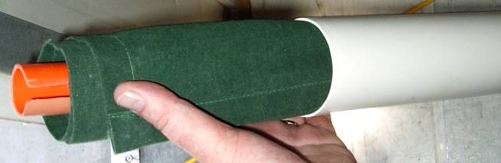

When required please contact Hugh Bomford by cell +64 21 045 8069

Off the radar
Mail has been returned from the following people's addresses. This may be because they have changed address or because their server considers the high quality correspondence from my addresses as 'spam'. Whatever the cause, if you know these people, please have them contact me if they wish to resume normal reception Douglas Stewart (Australia)
Pete Whiteman (Canada)
Nick van der Walt (New Zealand)

Long Range Desert Group
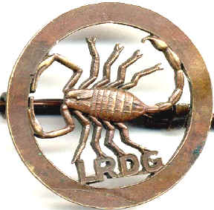
Badge of the LRDG

We were recently asked to see if two veterans of the Rhodesian Squadron of the Long Range Desert Group could be located. We are most grateful for the interest and response from subscribers to date which resulted in Alf Page being located in New Zealand and possible links to John Lowenthal MM in Australia. Well done people, a good result thanks to the positive aspects of modern communications.

I thought it would therefore be topical to give some background to one of WWII's famous units.

I try to make a point of finding common ground between Rhodesia and New Zealand to illustrate that we share a lot when it comes to military history. The LRDG is a prime example of this as you will see. Most of the following piece has been extracted from 'LRDG Rhodesia' by Jonathan Pittaway and Craig Fourie, with kind permission of Jonathan Pittaway.

The Long Range Patrol, which later became the Long Range Desert Group, was formed in Cairo in July 1940 in order to carry out very long range reconnaissance behind enemy lines in difficult terrain with little equipment.
Initially it operated in mostly unmapped areas of the Libyan Desert, but after the conclusion of the desert campaign in 1943 it was active in the Aegean and the Adriatic. During the five years of its existence it was involved in almost two hundred operations and many of the techniques it pioneered are still in use today.

Its founder was Brigadier Ralph Bagnold OBE, who, together with a group of interested officers, had carried out many exploratory trips in the desert before the war. During these expeditions they had developed the special equipment and desert techniques which the LRDG used.

At the start, the Australians were approached to man the unit. They turned the offer down as they had developed a policy of not allowing their troops to operate under British command on account of the British having shot numbers of Australians and New Zealanders for alleged cowardice and desertion during WWI. The New Zealanders had a similar policy but saw the advantages of the training and experience their troops would receive and so the LRDG was formed primarily of officers and men from the Second New Zealand Expeditionary Force. The LRDG was later to expand to include officers and men of the United Kingdom and Rhodesian Forces. (Editor's note: Just as the Australians and New Zealanders had learned to mistrust the British, later in history Rhodesians too experienced their duplicity). Later on, elements of the Indian Army were also included. All ranks were hand-picked volunteers.

The basic unit of the LRDG in the desert was the patrol which normally consisted of five un-armoured vehicles and twenty men. Each patrol was commanded by an officer and included an expert navigator, mechanic, wireless operator and medical orderly. They carried food and water to last a month and petrol for a round trip of 1500 miles.

In the Order of Battle from June 1942 the Rhodesians were in A Squadron which was formed of R and T Patrols (New Zealand) and S Patrol (Rhodesia). B Squadron was British with G and Y Patrols. The Kiwis and Rhodesians named their trucks after towns in their countries beginning with the letter of their patrol. The S Patrol Chevrolet 30 cwt. truck 'Shamva' is shown below.

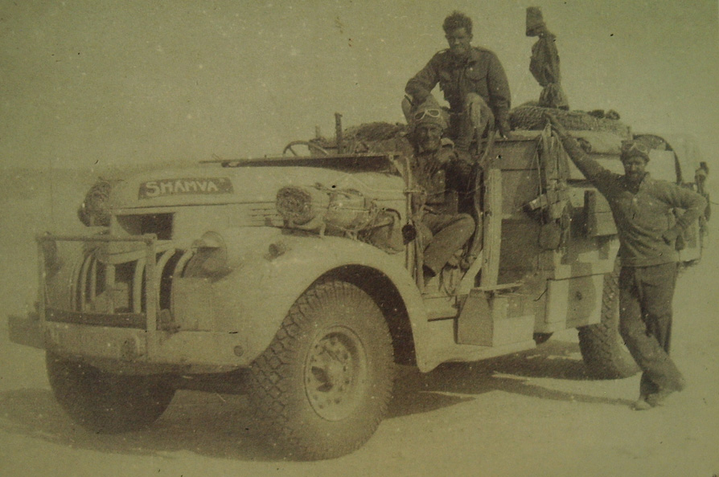

Although the LRDG's role was initially intended to be reconnaissance, its mobility, training and knowledge of the desert meant it was also able to play a highly effective offensive part in harassing the enemy.

During the desert campaign the LRDG participated in many successful raids, such as those against enemy outposts in Fezzan in 1940, 1200 miles from base across entirely unmapped country, and against the garrisons of Benghazi, Barce and Tobruk in September 1942. Operations in Fezzan were carried out in collaboration with the Free French from Chad and were the start of a long period of friendship with General Leclerc. The LRDG was also responsible for surveying the routes used by the Eight Army in their outflanking moves against the El Agheila and Mareth positions.

One of the most valuable and difficult tasks which the LRDG carried out during the desert campaign was a continuous watch on enemy movement along the main coast road. In 1942 this Road Watch was maintained day and night for two periods totalling nearly six months by a series of patrols which sent daily reports by wireless to base. The LRDG kept a census of enemy vehicles moving along the coast four hundred miles behind Rommel's front line. In this way the Eighth Army was provided with reliable intelligence on enemy reinforcement or withdrawal.

Equally important were joint operations with David Sterling's Special Air Service and Vladimir Peniakoff's, Popski's Private Army (PPA). David Sterling initially used the LRDG to insert his men for missions and then pick them up when complete. Willis Sadler MM, who was a renowned desert navigator and had served with the Rhodesian S Patrol, was one of only three survivors of a hand picked SAS patrol under David Sterling who became the first fighting unit to link the Allied Eighth Army advancing from the east with the American First Army advancing from the west in late January 1943. Stirling was captured on the way and, despite a number of escape attempts, spent the rest of the war as a POW. Interestingly, Reg Seekings DCM, was also supposed to be part of this patrol but did not get back from another mission in time. Reg Seekings later served in Rhodesia with the British South Africa Police's Police Anti Terrorist Unit (PATU). (Editor's note: When the war in Europe ended and Sterling was released from Colditz POW camp, he flew back to Britain. He was sent for by the War Office and asked if he would take a force to the Far East to fight the Japanese. He accepted, but before he left England the atom bombs ended the Japanese participation in WWII. Col. David Sterling DSO, OBE, could not wait to be demobilised and immediately went to Rhodesia to seek fame and fortune. He lived in Salisbury for a number of years and formed the Capricorn Society whose aim was to establish a modus vivendi by which all races, colours and creeds could live in harmony in Africa through the benefits of trade with the rest of the world.)

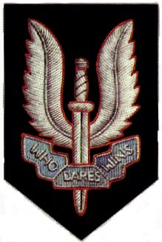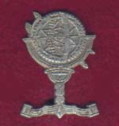
Badge of the SAS Badge of the PPA

For most of the desert campaign the LRDG was based in either Siwa or Kufra where it's own aircraft (Wacos and Lysanders) were based and maintained for evacuation of casualties, communication and making supply drops to patrols.

At the conclusion of the desert campaign in early 1943 the LRDG returned to the Delta and later went on to Palestine and Lebanon. The New Zealanders were returned to their units and the remaining LRDG patrols were reorganised to operate in Italy and the Balkans on foot, on skis, with Jeeps and animal transport, and to reach their target by parachute or sea. New types of equipment were devised and obtained in order to allow operations to be carried out in mountainous terrain where mechanical transport could not easily operate.

In September 1943 the LRDG was sent to the Aegean, where it became involved in ill-fated operations on the islands of Calino and Leros. In these operations about 100 men were killed, wounded or captured out of a total of 400.

In early July it was moved to Italy to operate under Field Marshal Alexander. Its primary roles were to obtain information on enemy movements, harass the enemy lines of communication, to support partisan groups and to provide watches on the movement of enemy shipping in the Adriatic. Patrols operated continuously in Greece, Albania, Yugoslavia and Italy, carrying out more than 100 successful operations behind enemy lines. These countries became what the desert had been to the LRDG.

Owing to Allied air superiority, enemy shipping could only move at night and lay up, camouflaged, in inlets during the day. LRDG patrols on islands and the mainland reported their positions to Royal Air Force and Royal Navy stations in the area. Under the cover of darkness Motor Torpedo Boats (MTBs) would then trap these ships in the inlets until rocket firing planes could eliminate them during daylight. Between the LRDG, the RAF and the RN, their combined operations accounted for over 100 vessels.

Coast watching was not the LRDGs only purpose in the area. There were also many reconnaissance trips. In addition, as the Germans pulled out of the Balkans, it became the LRDG's function, in co-operation with other units, to hinder their retreat. The end of the Axis in the Balkans meant the end of operations for the LRDG.

For a time there was a possibility of the unit going to the Far East. Eighty percent of its personnel volunteered for service there, but the Japanese were defeated sooner than expected.

The story of the unit that had carried out more operations behind enemy lines than any other combatant unit came to a close when the LRDG was disbanded on 21st June 1945. All that remained was the concept of the small patrol, able to operate by sea, land or air with unerring effectiveness.

This photo below is of the Rhodesian S Patrol Canadian Ford V8 abandoned in 1941 with a broken steering column. The photo was taken in 2001 and the vehicle is positioned at N 26° 59.120' E 26° 34.314' (Editor's note: Anyone able to sponsor a recovery mission of this vehicle for our museum collection, please contact me soonest!!)

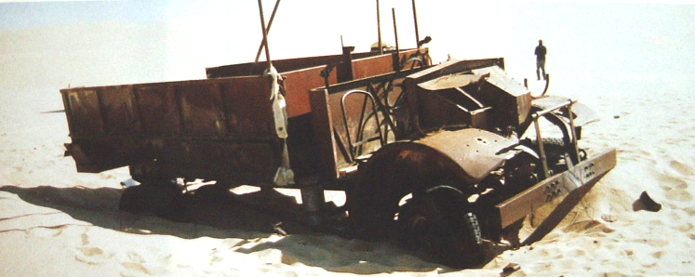

References and recommended reading:
LRDG Rhodesia by Jonathan Pittaway and Craig Fourie
SAS Rhodesia by Jonathan Pittaway and Craig Fourie
The Phantom Major by Virginia Cowles
Popski’s Private Army by Vladimir Peniakoff DSO MC
Kiwi Scorpions by Brendan O’Carroll
Bearded Brigands edited by Brendan O’Carroll
Barce Raid by Brendan O’Carroll
Providence Their Guide by David Lloyd Owen
The Long Range Desert Group by Robin Jenner and David List

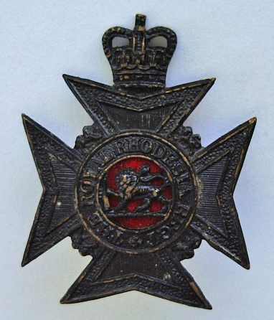 The History of the Rhodesia Regiment and the Royal Rhodesia Regiment 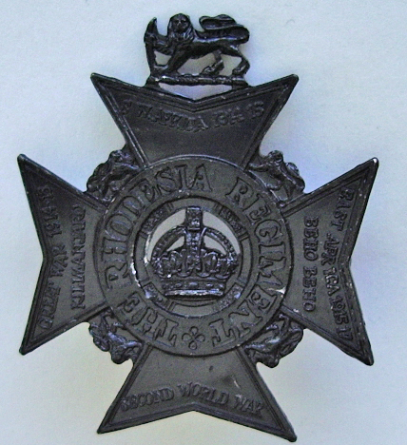

Alex Binda is making good progress with the book. Material in the form of narration and photos is trickling in. A number of people have made promises to write their memories down. All good stuff, but we need much, much more. There are not many Rhodesian soldiers who did not wear one of the two badges above at some stage. This is most probably the last chance any of us have to make a contribution to the preservation of the history of our unit. So it is vitally important that you act now.

Alex Binda writes:
Dear All,
A suggestion, as per "The Saints" I would like an appropriate title for the Rhodesia Regiment History to be chosen by former Rhodesia Regiment members. With the RLI history the appeal for a title resulted in 70% including the word Saints, i.e. 'Fighting Saints', 'Incredible Saints', 'the Saints', etc.

My own personal preference for the Rhodesia Regiment is:
MAIN TITLE:
"The Sunshine Soldiers"
SUBTITLE:
"The epic of the Rhodesia Regiment"

The only trouble with my main title is that I think there is already one like it out there (a spoof on some American Militaria). In any case it's your history so let's see if you can come up with an appropriate main title. (I will keep the sub-title as above).

Look forward to hearing from you, Alex.

You can go on line and read and contribute on the forum that I have set up which has a link on the home page of www.rhodesianservices.org or via this direct link http://pub9.bravenet.com/forum/738626929 Go and see what other titles have been suggested so far. (Editor’s note: since setting this piece up there has been a number of suggestions on the forum and direct to Alex – please do not delay your input)

If you are not able or comfortable going on line you can contact Alex:
3 Coquet Vale Mews, Station Road, Rothbury, Northumberland, England. NE65 7QH or by phone 01669 621767 or by email abinda@tiscali.co.uk

You can contact me:
PO Box 13003, Tauranga 3141, New Zealand or by cell phone +64 21 045 8069 or fax +64 7 576 9501 or email hbomford@clear.net.nz

Come on folks - we need you and you owe it to yourselves and the future generations to do this thing. This book is going to be huge. Alex cannot do it without your help. Dust off those memories, put away your inhibitions and write it down, or dictate it to someone who can write - Just do it!

Committee News
Electronic voting amongst the 91 financial members went off perfectly with a unanimous decision to adopt the revamped Association rules. The rules have been lodged with the Registrar of Incorporated Societies and we have made our application to become a Charitable Trust. The wheels of bureaucracy move slowly and we will keep you informed.

Museum News
Progress is being made with the two new cases destined for public display at the Classic Flyers Museum. Here is proof of that statement with Colin Logie and Tony Fraser taking time off paid work to sweat it out on the Trooper Simon Clark Display - tribute to New Zealanders who served in Rhodesia:

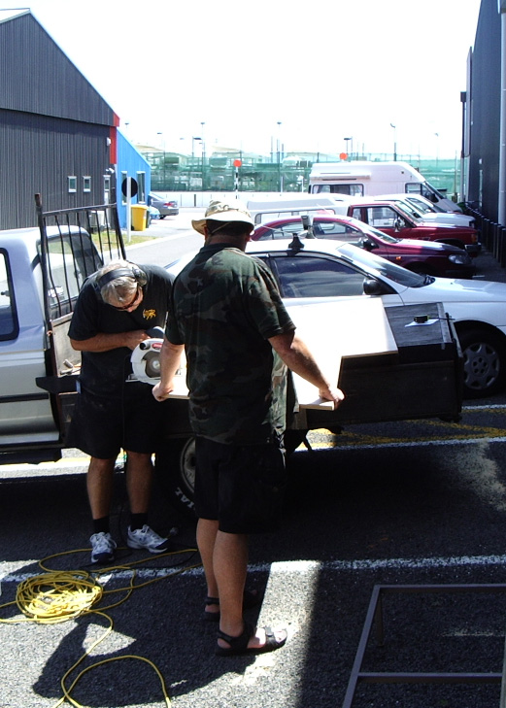

Sylvia Logie has researched and written up the background that we will use in the Ian Smith memorial display. As previously mentioned this display will focus on his service in the Royal Air Force. We need photos of Pilot Officer I.D. Smith in uniform and from that period. If anyone can assist please contact me urgently.

We have an open import license for a number of weapon types that were used in Rhodesia. This is perfectly legal and is authorised by the NZ Police. Most of these weapons are available in various conflict zones. We require someone in a position to legally obtain these to assist us. We did have them all ready to be sent from Afghanistan, but because they were obtained by a New Zealand serviceman and New Zealand has a law that serving members of its forces cannot take weapons out of a war zone, we were snookered. So any of you serving men who think you can help, please contact me and I will give you a list of what we are authorised to import.

As part of the development of the displays at Classic Flyers we are making up an information brochure. We need good clear images of various Air Force squadron badges. In particular 44 Rhodesia Sqn, 237 Rhodesia Sqn, 266 Rhodesia Sqn, Royal Rhodesia Air Force, Southern Rhodesia Air Force. If you can assist please contact me. (Editors note: Since writing this piece one person in Zimbabwe has offered the material in the form of prints. If someone is travelling from Zimbabwe to New Zealand or to a country where they can be reliably posted from please contact me urgently).

ANZAC Day 25th April 2008
Preparations are already taking place for this day which falls on a Friday this year. A number of us will travel from Tauranga on the Thursday and return on Saturday. If any of you want to link up with us before ANZAC please contact me for details regarding the Thursday night. We hope that some of you Aucklanders will last a bit longer at Hobsonville this year!! We also hope that "Osama bin Walking" brings the fare for a 'Rixi' or one of the Tauranga crowd will stay legal so you could catch a glide with us mate!

The ANZAC Day programme will be made public closer to the time but you need to plan on being at Hobsonville between 9 and 9.30 am. Let's make this the biggest parade yet.

The Bookshelf
Recently there have been a lot of new Rhodesian based books published. I am always happy to promote them and in return I ask that they donate a signed copy to the Rhodesian Services Association Annual Auction.

All the books and audio visual disks that I stock and sell are listed at http://www.rhodesianservices.org/Books.htm I would like you to note that income from sales from these items is directed to me and not the Rhodesian Services Association. The Association does benefit indirectly from a portion of these sales.

Latest arrivals are Masodja - The History of the RAR; The Kevin Woods Story - Living in the shadow of Mugabe's Gallows; and two books by former members of the RLI: Lost In Africa by Stu Taylor and Shadow Tracker by Keith Nelson.

On the way (and should be with me shortly) are DVDs of the Saints Launch. For all those who were unable to attend the incredible launch of the RLI's regimental history The Saints - The Rhodesian Light Infantry in June last year, you can now purchase a DVD on the event. This gathering of former soldiers took place at the Guard's Museum, Wellington Barracks, London on the 14th of June and saw the band of the Scots Guards beating retreat in tribute to the RLI. Charlie Aust, the last commanding officer of the RLI took the salute, the first time he has been honoured in this way since the RLI's final parade in 1980. The DVD will be NZ$35 plus postage.

The second edition of The Saints - The Rhodesian Light Infantry is being printed and I will let you know when my stock arrives.

Books that I will carry when they are released in March 2008: Out of Action by Chris Cocks which is his powerful sequel to his bestselling Fireforce - One man's war in the Rhodesian Light Infantry; Kenya Cowboy by Peter Hewitt which is his personal account of a British Policeman's experiences during the Mau Mau Emergency, this third edition includes a postscript and a foreword by Dr. Lonsdale of the University of Cambridge.

The good folk at John Edmond's company, Roan Antelope Music recently wrote:
Dear Rhodies and Friends,

We thought it would be a great idea to kick off the New Year with some good visual Rhodie footage in the form of the John Edmond - Troopie Songs DVD together with a great Cammo Cap Combo.
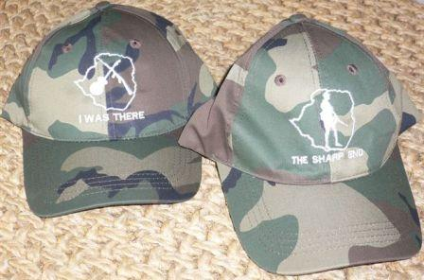

Both these caps have an outline of Rhodesia on the front, one has a crossed rifle and guitar and the logo reads: "I was There" and the back "John Edmond Troopie Show" and the other have an outline of Rhodesia with a silhouette of a troopie and the logo reads: "The Sharp End" and the back "Troopiesongs were there".

Caps can be viewed on the web-site: www.johnedmond.co.za The DVD contains authentic film from the era of the Rhodesian Bush War, this unique footage portrays and strengthens the meaning of John's Troopiesongs like: Green and white, Wish I was a blue job, Pick yourself up, Daisy, Green Leader, The Whistling Troopie, The candle that burns, A soldier's dream, The Gunship Calypso, George, Flat dog Blues, It makes me so Sad, together with the re-enacted scenes it blends the old with the new.

So come-on, put your troopie cap on, open a chibuli (beer for the non Rhodesian subscribers) and start watching.

The cost of this combo DVD plus 1 Cap, packaging and postage is: R230 US$ 50 UK£26 Au$ 65 NZ$ 75 Order now! This offer runs for Feb ONLY, starting 1st February 2008!

This combo can be ordered from:- ROAN ANTELOPE MUSIC www.johnedmond.co.za or you can forward your details, c/card, name, postal address and tel. no. to:- jredmond@mweb.co.za or make a direct payment to:- J. Edmond F.N.B. Bela Bela code 260347 AC No 542000 51694 Fax: 086 6011 817 / Tel: +27 (0)14 735 0774

We look forward to hearing from you.
The bush babies, Annemarie and Teresa from a drenched, wet Bushveld, Limpopo Province

A number of people have been asking me for Wrex Tarr CDs. John Edmond and Roan Antelope Music stock the only legal Wrex Tarr, Chilapalapa CD in the world and it contains the whole collection check the website www.johnedmond.co.za for details.

Chris Higginson writes:
Hi Hugh, I have organised a better way (I think) to download the Rhodesian Memories E-book that will be more simple for most people.

If they follow the procedure below, they will be able to download the book and have a look at several chapters for free. If they want to read the rest of it, they will need a pin number from me.

I would also like contributions from Rhodesians writing about their memories anytime prior to 1980. I am interested in Civilian Life experiences, before they all fade away.

Search on the Internet for "yahoo.co.uk"
One of links will be "sign into yahoo".
Click on that, and on the account enter downloadebook31@yahoo.co.uk
The password is zimbuggered
This will open the account as though it is your account.
Have a look in the "inbox" and you will find a message titled "Rhodesian Memories E-book "
Click on that message, and then you will see the attachment.
This is a .exe file, it is safe for you to download onto your computer.
I suggest that you download it onto your desktop.
When that is done, click on the icon and the book will open.
Click through it and you should see chapters etc.
When you have done that you will need a pin, email Hugh Bomford for it, who will send it to you. Every sale via Hugh generates a contribution to the Rhodesia Services Association.

The reason for this complication is that some browsers won't let the e-book through, and this method bypasses all of that. Please do not abuse this system, as others would like to benefit from this download.

This E-book only works on PCs, not MACs.

Sorry about that.

Cheers Chris

Please remember when you buy anything from our sponsors, supporters and donors that you see advertised in this newsletter or on the Rhodesian Services Association website, make sure that you let them know that you were referred by the Rhodesian Services Association so that they know the undoubted worth of supporting us in the future. Thank you.

CQ Store: visit http://www.rhodesianservices.org/The%20Shop.htm to see what is in store for you

Stable Belts
Here in New Zealand it has been the practice of the SAS members (and one or two others) to wear their stable belts at ANZAC Parades. I have received emails from a number of you in New Zealand and overseas asking me if we can supply stable belts.

We have found suppliers and we are currently obtaining quotes. Before we make any orders we need your feedback. Even those who have already asked, I need you all to write to me again in case I have missed anyone out. Please email me if you would be in the market hbomford@clear.net.nz

The stable belts we will be stocking will be in sizes to suite the mature frame. We will aim to be retailing them at around NZ$50 each excluding postage. It may not be practical for us to stock all unit belts as the set up costs for some of the smaller units like Rhodesian Psychological Operations Unit may be prohibitive given that they had an unusual belt buckle.

At this stage we believe that we should be able to get belts to suit the following units:
Rhodesian Artillery
Rhodesian Corps of Chaplains
Rhodesian Corps of Engineers
Rhodesian Corps of Signals
Rhodesian Light Infantry
Rhodesian Military Police
Rhodesia Regiment
Rhodesian SAS Regiment

Sales for the month of January have been great. Remember that profits from the CQ store help us maintain and develop our museum displays.

This is a list of our current stock

ITEMS EXCLUDING POSTAGE | PRICE in NZ$
4RR Hackles (new stock arriving any day) | $15
Berets | $50
‘Gun control’ t-shirts | $20
Lion & Tusk Baseball Caps | $23
Lion & Tusk Beanies | $20
Lion & Tusk Dog Tags ‘silver’ or ‘gold’ | $30
Lion & Tusk Polo shirts - black or green | $36.50
Lion & Tusk T-shirts - black or green | $30
Lion & Tusk Women’s shirts | $30
Number plate surrounds – suits NZ size lates | $12
Regimental Badges – RLI, Intaf, RAR, RDR, BSAP, Grey’s Scouts, RRR, RR, Service Corps, Staff Corps, RWS, DRR and more | Priced from $20 – inquire for details
Rhodesian Army Recruitment poster copy “Be a man amongst men” | $15
Rhodesian General Service Medal full size medal copy with ribbon | $100
Rhodesian General Service Medal full size ribbon | $10/length
Rhodesian General Service Medal miniature medal with ribbon | $35
Rhodesian General Service Medal miniature ribbon | $10/length
Rhodesian Light Infantry tie | $35
Unofficial Rhodesian Combat Infantry Badge | $23
Various medal ribbons – please inquire | POA
Various small embroidered badges (RLI, BSAP & Nyasaland Police) | $5
Zimbabwe Independence Medal full size copy with ribbon | $50
Zimbabwe Independence Medal full size ribbon | $10/length
Zimbabwe Independence Medal miniature medal with ribbon | $35
Zimbabwe Independence Medal miniature ribbon | $10/length
‘Zippo’ type lighter | $25

The Global Forked Stick
The Rhodesian Army Association (RAA)
The RAA in England has a number of stocked items for sale that may be of interest to you. They have ties from £11 excluding postage for the following:
Rhodesian Army Assn.
Rhodesian African Rifles
RAR Regimental Assn.
Rhodesia Regiment
Royal Rhodesia Regiment

They also have blazer badges, polo shirts and baseball caps for RAA and RAR as well as other units as required; historical prints - Masodja by John Hopkins, Historical Bulawayo by J C Aust.

To order or get more details please contact Ian 'Scotty' Robertson ianscottie@hotmail.com or David Heppenstall d.heppenstall@virgin.net

Rhodesian Engineers
The webmaster of SASappers.net has asked me to remind all South African and Rhodesian Military Engineers that they can register with the website www.sasappers.net Guests are also welcome.

Rhodesians Worldwide Magazine
This magazine has been keeping the spirit alive for the last 24 years. Produced quarterly it makes a very good present for someone else or to buy for yourself. Subscriptions are NZ$34 or approx US$22 per annum which puts it within everyone's reach.

If you are in New Zealand contact me and I will send you a freebie introductory copy or if you are elsewhere contact Chris and Anne Whitehead by post PO Box 22034 Mesa, Arizona 85277-2034 United States of America or phone: (480) 924-0431 or fax: (480) 924-0269 or you can Skype them at Skype name: Shambuki or Email rhodesia@rhodesia.org

No more excuses people, order up your own copy today!

Australian War Memorial, Canberra, Australia
An old Rhodesian soldier, an Original RLI soldier and SAS from Federation days, Michael Davies, is a volunteer guide at the Australian War Memorial in Canberra. If any of you intend going there let Mike know and he may be able to show you around. His email is michael.davies3@bigpond.com.au

The Bishop (no, this is not going to be a dirty joke involving a cleric and an actress!)
Where in the world is Bishop Muz (the Reverend Able Muzorewa, the first elected black Prime Minister) is a question that was asked of me recently. I shrugged and muttered something like "who cares, he would have been just as bad as the current incumbent given that nowhere in Africa can the indigenous stay away from corruption".
Imagining that Muz was probably in America somewhere with his Methodist supporters, I was surprised to read this piece below a few days later as extracted from Zim News entitled "White farmer vows to challenge Muzorewa farm grab, by Lance Guma"

"Former Zimbabwe-Rhodesia Prime Minister Bishop Abel Muzorewa is at the centre of a legal wrangle after taking over a farm belonging to a white farmer in Mutare. Muzorewa moved onto Cavalla Farm 4 months ago, despite the fact that Lodewyk Van Rensburg bought the farm in 1989, nine years after independence. The Bishop who led the country in 1979 under a short-lived coalition government with Ian Smith is said to have produced an offer letter from State Security and Land Resettlement Minister Didymus Mutasa. This is despite Vice President Joseph Msika ordering the cancellation of all offer letters issued after January 2007. Reports say at least 75 farm workers at Cavalla Farm have already lost their jobs to make way for the bishop and his people. The farm owner Van Rensburg, who is said to be a devout Christian, voluntarily gave up 700 hectares of the 1200-hectare farm for redistribution some six years ago. He told the UK Daily Mail that 'ultimately the Lord will judge what has happened. But it does make a mockery of his position as a man of the cloth.' Muzorewa meanwhile remained defiant saying he just wanted to have land which was taken from his forefathers without compensation. He called his action 'a correction of injustice.' The matter is set to go to court in February.

Van Rensburg's lawyers have already written to the police seeking Muzorewa's eviction but so far nothing has happened. The offer letter to Muzorewa is peculiar in that he was once the sworn enemy of Zanu PF during the liberation struggle. Zanu PF slogans at the time referred to him as a 'puppet' for colluding with the white regime of Ian Smith. That same 'puppet' is now grabbing white owned land with the assistance of Mugabe's government.
Journalist, actor and writer Norman Madawo has described Muzorewa's actions as 'satanic'. Madawo who recently launched his book 'White Farmer-Black Warrior: A friendship out of tune' said it was wrong for Muzorewa to hide behind the excuse of correcting a historical injustice. 'You cannot solve one injustice by creating another.
All this means is that the next government will have to reverse whatever is being done now,' he said. Madawo said the media hardly highlight the plight of farm workers who are the most affected by the upheavals. This he says drove him to write his book and explore the motivations for the land reform exercise, the relationships between white farmers and their workers among other things."

Extract from the ‘The Pride’ Newsletter of the Australian Branch of the Rhodesian Light Infantry Regimental Association
This is an extract from 'The Pride', newsletter of the Australian Branch of the RLI Regimental Association. They encourage membership over all categories which include Full for 'badged' members of the RLI; Affiliate for immediate family of deceased Full members; Associate for anyone else who have no ties to the RLI but wishing to support and receive newsletters etc. I would recommend anyone interested in joining should contact Tony Young by email ozemedic@bigpond.net.au For other branch details visit http://www.therli.com/

"As Digger has mentioned, finding an appropriate home for the Troopie has not been an easy task. During the course of the investigation & decision making process, a suggestion was made which I think many might find quite thought provoking and indeed, titillating.

Before going into greater description it should be noted that this suggestion was made when it was still believed that we had to try and find the estimated $15,000.00 needed for repair of the damaged Troopie. (Editor's note: the Troopie has been repaired and is safely in a warehouse awaiting his plinth to be made and then to be moved to his place beside the stream and lake at Hatfield House, the home of Lord Salisbury.)

'Operation Excalibur' involved spending the anticipated repair costs on sending the unrepaired Troopie back to its only true home - Rhodesia. Naturally, the very first thought that comes to ones mind is that this would be insanity for it is without question that Mugabe and his henchmen would immediately confiscate and destroy the Troopie.

This concern is valid only if Mugabe and his lot could actually get their hands on the Troopie, which then of course raises the question, would there be anywhere in Zim that would be safe. The answer to this is yes - if the Troopie was deep underwater, somewhere in an undisclosed location on the bottom of Lake Kariba.

On initially hearing this most gasp in horror at the thought that the Troopie might never be seen again, however when one thinks about it, very few of us are actually going to have the opportunity of seeing the Troopie "in-person" again, even though it is in the UK.

So, what's the difference……well, think about this:
- The Troopie got to go back to its real home - parachuted into an undisclosed & deep part of Kariba.
- After announcing to the world-wide media that the Troopie was home, it would no doubt drive Mugabe and his lot demented knowing it was somewhere in Zim but, unable to actually do anything about it.
- The passive torment of Mugabe and his highly superstitious mob would be compounded if a story was circulated that, like Excalibur, when the Troopie reappeared ZANU-PF rule would end.
- We could have produced a video of the complete operation (from start to finish) which would likely have gone down in the anals of history as one of the most audacious Commando operations of all time.
- A painting or sketch of Lake Kariba could have been produced with a representation of the Troopie hovering over the waters of Lake Kariba, and when asked by people about the significance of this strange painting, we could have proudly recounted the story of Operation Excalibur and how we got the final last laugh against Mugabe & ZANU-PF.
- If and when sanity returned to Rhodesia, the location of the Troopie could be disclosed so that it could be recovered, repaired, and given a place of honour on dry home-land.

Oh well, it was an intriguing concept whilst it lasted……….maybe one day I will be able to afford to visit Mud Island (UK) to see the Troopie (and Queen's Colours) at Hatfield House."

Quote for the month
“There is no ‘ex’ in Rhodesian” – Ian Douglas Smith in private conversation with someone seeking his autograph.

The Last Word
John Winter sent me this for inclusion:

The Silver Thread by S Weatherall, The Bard of Gatooma, October 2006
(Editor’s note: We believe that ‘S Weatherall’ is Syd Weatherall, if anyone has a current email address for him please send it to hbomford@clear.net.nz Thank you).

Whisper not to me of Xanadu, stately dome of Kubla Khan
Or those ageless warriors who brighten history's span,
I know of Omaha's grim beach and Iwojima's sands
The fallen always cherished and whose glory ever stands.

But I have heard of one fair land with places as sweet dreams
Of a fairyland of beauteous charm hewn from virgin realms,
Ah, savour Mavuradonna's heights and Chimanimani's peace
Oh land of sweet delight and true patriot's release.

T'is also said their strife was fair and noble was their cause
But honour with deceit was paid and almost without pause,
Scattered they were to far flung lands with little worldly gain
Save for that blessed hope that once their dear land may reclaim.
There is still the mystic silver thread that binds this gallant band of comradeship, travail and ah, the Regiment's last stand,
They say that hope still lies awake for some eternal hour
So tarry friend for thou mayest yet still smell such sweetest flower

Until next time - go well

Cheers
Hugh

This newsletter is compiled by Hugh Bomford, Secretary of the Rhodesian Services Association. It contains many personal views and comments which may not always be the views of the Association or Committee.

If for any reason you would like to be removed from the mailing list, please send an email to hbomford@clear.net.nz with the word ‘remove’ in the subject line or body.

